**Interim Report**

**Project Title:**

**Estimating personal energy expenditure with location data**

**Student Name:** Vladimir Hartmann

**Degree program:** BSc Computer Science

**Department:** School of Informatics

**Candidate Number:** 52665

**Project Supervisor:** Dr. Martin Berger

**Year of Submission:** 2012

**2. Statement of originality**

**3. Summary**

Modern society is putting unsustainable demands on personal wellbeing as well as the wellbeing of the planet. Human pressure on the biosphere is greatly exceeding global sustainability. While there is an ongoing discussion about an importance of achieving sustainable state of the planet, there seems to be a lack of personal accountability towards this problem. From the number of proposed solutions, the one attributing an equal allocation of emission rights to each person on the Earth has gained increasing recognition. However implementing such a solution imposes great challenges as energy estimates for each person must come from various meters, sensors and location systems distributed globally. I propose a simplified version of estimating personal energy expenditure as an intermediate step towards global personal energy metering and raising awareness of energy consumption by individuals……..

…..

….

**4. Table of Contents**

**5. Introduction**

* **Motivation, Aims and objective**

“Every day each of us consumes a significant amount of energy, both directly through transportation, heating and use of appliances, and indirectly from our needs for the production of food, manufacture of goods and provision of services” [1]. The aim of this project was to create a new interactive application, which would measure personal energy expenditure. Research of previous attempts in solving this problem has been carried out to identify possible gaps for developing a simple application capable of calculating energy expenditure estimates….

Modern society is putting unsustainable demands on personal wellbeing as well as the wellbeing of the planet. Pervasive sedentary lifestyle has been creating many health conditions while excess in energy consumption has had adverse effects on our ecosystem. There is a clear connection between personal and planetary wellbeing and actions that help to improve our own health often have a positive effect on our environment. Location data such as GPS tracking can be utilised to address both issues. As it is most frequently collected piece of contextual data in computing, it can be applied to many healthcare applications. This technique offers a number of improvements over traditional methods, which involve carrying a dedicated accelerometer device.

**Aims and objectives**

**Aim**

Estimatepersonal energy expenditure and provide healthy recommendations for personal and planetary wellbeing.

**Objectives\***

Primary:

* **Design and develop the Personal Energy Meter (PEM), an iPhone application**
* **Design and develop an Interactive Dynamic Website**

Extensions:

* **Ensure that both systems are reliable and accurate**
* **Validated with real biomedical measurements**
* **Extended functionality for better user experience**

*For details on objectives see Requirements Analysis (Project after negotiation) section

….

….

* **About this project**

……

….

**6. Background**

Ongoing progress is being made by various universities and institutes to address the issue of personal energy expenditure monitoring. This is due to the fact that the global economy is not able to meet the minimum conditions for sustainability. The Rio Declaration of 1992 and the United Nations Millennium Development Goals have demonstrated that human demand for ecosystem goods and services exceed the biosphere's total capacity. A fundamental solution is to manage food, fibre and energy consumption and maintain or increase the productivity of natural and agricultural ecosystems. From the number of proposed solutions, the 'shrink and share' framework has gained increasing recognition. This solution emphasises an equal allocation of emission rights to each person on the Earth and has been established by European Parliament as a basic principle to reducing global emissions of carbon dioxide [2]. Simon Hay at University of Cambridge proposed a 'Global Personal Energy Meter' (PEM) [1], device which can record and apportion an individual's energy usage. Architecture of this PEM would consist of a global sensor network and devices such as smartphones would communicate with it and receive estimates of energy used by individual. Data from a 'world model' (recommended energy usage allocations) would be fed into PEM to estimates keep up-to-date. Further research undertaken by Simon Hay, this time together with Stamatina Th. Rassia , Dr. Alastair Beresford and Dr. Nick V. Baker include 'Movement dynamics in office environment' [3] and 'Estimating personal energy expenditure with location data' [4]. The task of this research was to explore the relationship between indoor environments and physical activity by gathering location and physical activity data. Devices used in an experiment were Active Bat location tracking device and GTIM Actigraph. To estimate personal energy expenditure an energy consumption model had to calculate gravitational and kinetic energy.

Tracking people’s movement has been known for some time now. Romans used odometer calibrated to steps, although technically not a step counter, the idea was similar. Leonardo Da Vinci designed a mechanical pedometer, which was used for civil and military purposes. Most of the movements tracking solution on the market today make use accelerometer, which is a device able to monitor any movement in X, Y and Z coordinates. This approach however requires wearing a special device, which might not me convenient. It is also not accurate in many cases (user can cheat by only moving the device in certain way to mimic the actual walking/running).

Proposed approach in this project uses mainly GPS data to track users movement. This can be supported (with project extensions) by accelerometer data and data obtained from signals of the heartbeat. All three technologies combined can produce very accurate and reliable system.

**7. Professional Considerations**

**Code of Conduct**

The project raises the issue set out in section 1, subsection (a) of Code of Conduct. Implementation of Personal Energy Meter (PEM) requires use of the iPhone Location Services that gather location data of user. It must be assured that any storage or transfer of this data is secure and not leaked.

PEM is in accordance (only if the system is used for commercial purposes) with section 1, subsections (c) and (d) of Code of Conduct, as the system will be distributed via the Apple’s App Store to which anybody can have access.

Further issues may rise from the section 2, subsections (a) and (b) of Code of Conduct, if the systems developed would be used for commercial purposes. As part of my project is to undertake the challenge of learning new programming language and iPhone development, no full competence for these has been obtained yet. These issues have been taken into consideration however for future professional career.

**Code of Good Practice**

Although about 70% of the document is closely related to this project it will be an excellent guide to ensuring that it is done correctly with highest possible quality.

Study of this document will be included as a milestone in this project.

**Planning**

Introduction

As the nature of the project requires learning new programming languages, frameworks and toolkits, project becomes challenging and therefore there might be unexpected changes. This might require backtracking and re-designing the system and therefore Scrum software development method was chosen. The Scrum is a general agile method with focus on managing iterative development. There are three phases in Scrum:

This is very suitable method for software projects such as the final year project because of the limited time available and unpredictable forecast of the development process. Requirements of learning new programming languages, frameworks and toolkits make the project challenging and therefore there might be unexpected changes which might require to backtrack and re-design the system.

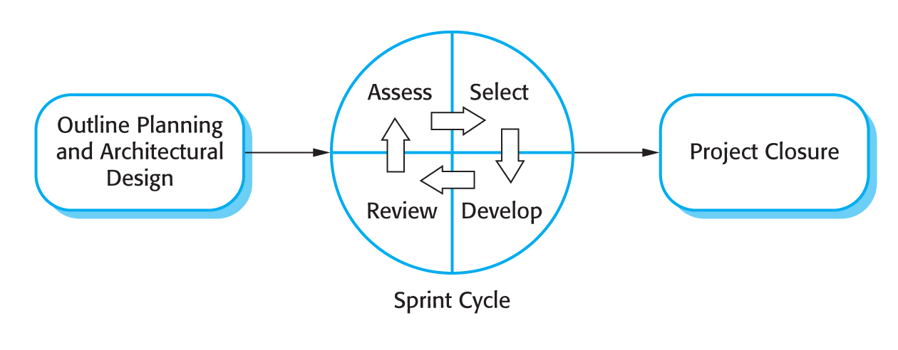

[REF – Chapter 3.4]

1. Outline planning and architectural design

This phase was concerned with general objectives and requirement analysis for the project and with designing software architecture. Former requirements specification section was very detailed and less suitable for agile development and therefore data flow sections have been omitted. Most of the underlying functional requirements have been left unchanged, but there have been some additions or improvements to them as the project development progressed. Some features have been renamed to convey better meaning and for consistency. There was a need for PEM’s user interface changes with subsequent knowledge of an iPhone development acquired.

1. Sprint cycle

Series of sprint cycles followed the previous phase where each cycle developed an increment of the system. Cycles had lengths 1-4 weeks. At the beginning of each cycle, meeting with a customer/supervisor took place where features of both applications were *assessed* and *selected* for the *development*. First half of the meeting was used for *reviewing* already completed cycle. Details of the meetings in appendices show what has been *assessed*, *selected* and *developed*.

1. Project closure

Project closure phase wraps up the project, produces required documentation and draws conclusions.

**Project Plan**

Following is the initial project plan parts of which became obsolete later in the development.

**Project Outline**

The goal of the project is to develop a system that can estimate user’s energy expenditure and advice him/her about their personal wellbeing or about wellbeing of the planetary environment. The main idea is to implement an iPhone application, which will be able to receive GPS data and perform live calculations of Calorie expenditure and CO2 emissions. The basic implementation of this application requires that user performs some activity, which involves location movement.

More advanced implementation (using the project extensions) will allow user to perform any physical activity. This means that except GPS data, the application will be able to process heartbeat signals and accelerometer data.

The system is split into two parts, the Personal Energy Meter (PEM) which is an iPhone application and web application (PEMWEBAPP). Implementation of PEMWEBAPP has two purposes. First, is to receive data from PEM and present them in better graphical way using all real estate of computer monitor. Second, to demonstrate skills acquired during a course of study.

**Project Schedule**

There are several important milestones for this project and each of those has several key tasks that must be performed. More information is given in the phase plan.

The main milestones for the project include:

* **General research** of the problem the project is concerned with, and production of the project plan overall (including the  creation of this document as a guideline for the rest of the project, as well as being used  as a general schedule).
* **Requirements Analysis**, aimed at finding all ambiguities,  and determining exactly what the customer/user wants. This will include a decision on which  design model to use.
* **Design of the system**, which will help to determine how the applications will be structured given the limits and freedoms determined within the requirements Analysis phase.
* **Implementation and Testing**, the stage in which the actual software systems are developed, using the designs created in previous stage. Many different ways of checking that the completed applications are of a good standard and implementation is on schedule will also be included here.
* **Evaluation** stage will be concerned with answering the questions whether the systems implemented solved given problem, how well they solved it and how accurately the solution matches with requirements. Here will also be included material about how accurate the results from the PEM were to real biological measurements of energy expenditure.

**Phase plan:**

**General research – phase plan**

1. Literature reviews
   1. Research materials about GPS systems
   2. Research materials about Accelerometer
   3. Research materials about human wellbeing by physical activity
   4. Research materials about human calories expenditure
   5. Research materials about iPhone development and iOS SDK
   6. Research materials about Objective-C
   7. Research materials about Java EE 6, Tomcat, GlassFish
   8. Follow the book “Projects in Computing and Information Systems”
2. Meeting with customer/user
   1. Meetings with project supervisor
   2. Getting feedback on application prototypes from friends
3. Write the project proposal

**Requirements Analysis – phase plan**

1. Requirements discovery
   1. User scenarios
   2. Customer/supervisor meetings
2. Requirements classification and organization
   1. Organizing and clarifying what has been gathered from customer/users
3. Requirements prioritization and negotiation
   1. Negotiating possible changes with customer/users and advice them on better suitable alternatives to meet the deadlines/budged
4. Requirements specification
   1. Clearing out ambiguities
   2. Producing a document which will act as a contract between customer and developer
5. Write the interim report

**Design – phase plan**

1. PEM (Objective-C)
   1. High and low level design for Profile manager
   2. High and low level design for Login with authentication
   3. High and low level design for Database (Apple’s Core data)
   4. High and low level design for Statistics
   5. High and low level design for GPS tracking
   6. High and low level design for Live energy expenditure calculation
   7. High and low level design for Data transfer
2. PEMWEBAPP (Java)
   1. High and low level design for Login with authentication
   2. High and low level design Profile view
   3. High and low level design Database (MySQL)
   4. High and low level design Statistics

Subtasks of tasks above will consist of creating appropriate architectural design and UML diagrams, which will be later used in the implementation stage.

**Implementation and Testing – phase plan**

The aim is to start as soon as possible without having to wait for total completion of solid software design – hence the agile development model. Modularization is used and attention is focused on some parts of the project, which will not change. In this way, implementation can start with only partial design. This strategy will be necessary in order to allow for any unforeseen complications in the design or implementation.

1. Set up version control in Git
2. PEM development
   1. Implement Profile manager module
   2. Implement Login with authentication module
   3. Implement Database module
   4. Implement Statistics module
   5. Implement GPS tracking module
   6. Implement Live energy expenditure calculation module
   7. Implement Data transfer module

Subtasks of the PEM development tasks will consist of:

* Interpreting high and low level design diagrams in Objective-C language and trying to predict any deviations from the design.
* Coding the agreed design
* De-bugging
* Refactoring for better code structure
* Writing a test cases

1. PEMWEBAPP development
   1. Implement Login with authentication module
   2. Implement Profile view module
   3. Implement Database module
   4. Implement Statistics module

Subtasks of the PEMWEBAPP development tasks will consist of:

* Interpreting high and low level design diagrams in Java language and trying to predict any deviations from the design.
* Coding the agreed design
* De-bugging
* Refactoring for better code structure
* Writing a test cases

**Evaluation – phase plan**

1. Evaluation of how well the systems meet customer/user requirement
   1. There will be feedback received from the customer/user throughout the development process. Prototypes of the systems will be released in intervals to ensure meeting the requirements as closely as possible
2. Evaluation of how the systems are reliable
   1. One of the extension features is to ensure the reliability of the PEM system by researching deep into iPhone Location Services and Accelerometer and utilizing full power of the hardware. Task of this part of evaluation will be proving the reliability of PEM in extreme conditions where two or more technologies might by interchanging in live energy expenditure monitoring mode.
3. Evaluation of how the systems are accurate
   1. In this part of the evaluation phase real biological results of obtained from health centers or fitness centers will be compared to those calculated by PEM. Results maybe obtained on request from staff or by measuring calorie expenditure of myself on treadmill. This is very important part to having a product, which has some value at the end of the development. Note that it is also one of the extensions and not a priority to complete project.

**Time estimates**

Some progress on the project has already been made in form of gathering required literature, Requirements Analysis and PEM prototype implementation. Documents produced in the Requirements Analysis phase should only change if the extensions will be implemented and they will only change in terms of adding some functionality and not changing a core specification.

Work expected in second term should include completion of high and low level design and more usable prototypes of PEM and PEMWEBAPP with most of the required functionality. Time has also been allowed for writing a draft report.

Activity-on-node diagrams below show estimates of the time to complete both PEM and PEMWEBAPP systems. The figures have been estimated with constraints of learning new programming language in mind.

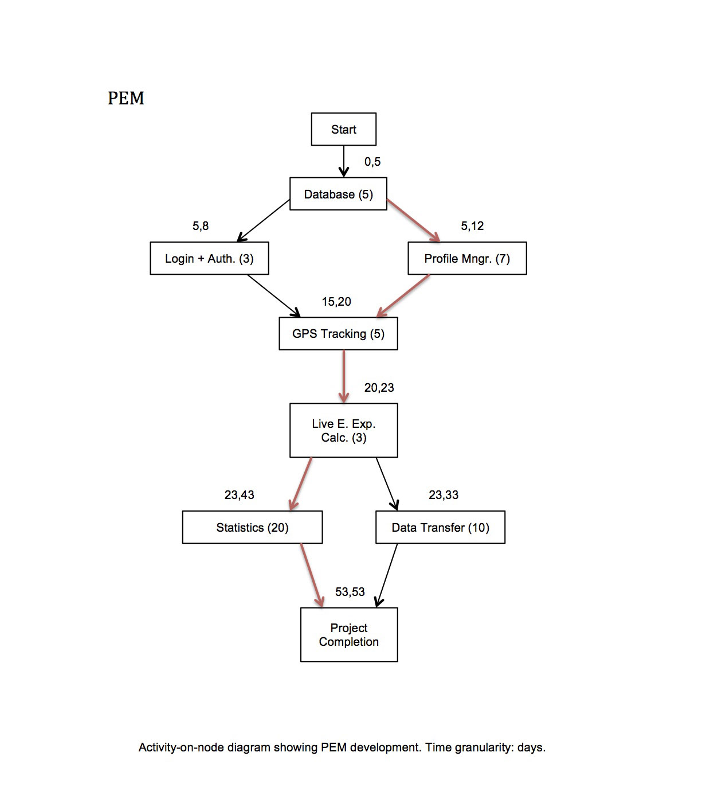

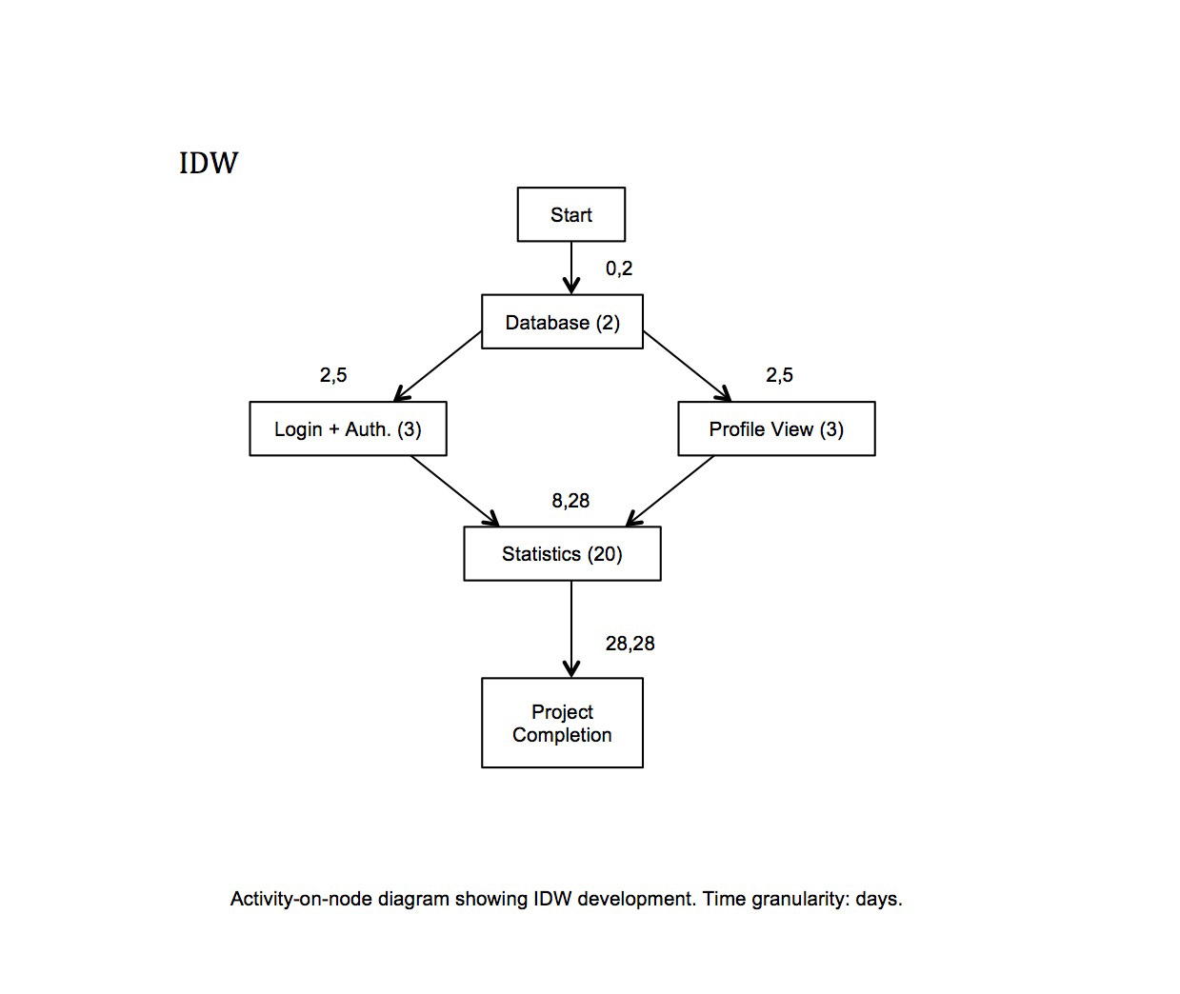

**Requirements Analysis**

Requirements discovery

Requirements discovery has been carried out on three individuals. The project supervisor/main customer Martin and two friends of mine Tim and Richard. The requirements are very vague and high-level but refined throughout the stages of the Requirement Analysis.

**Collected scenarios**

Scenario 1

Martin has a busy lifestyle in which time to rest and sleep is very precious. Therefore he would like to find a way of measuring and controlling the amount of energy he uses doing certain activities such as walking, running, cycling, working out in the gym or climbing stairs. As he is also very aware of the carbon footprint on the environment he would be interested in how much he could eliminate the emissions by changing his forms of transport.

Scenario 2

Tim spends lots of hours in an office doing a sedentary job. To preserve his wellbeing he wants to know each day/week whether he had enough recommended physical activity. He would like to get accurate calorie expenditure results with healthy advices and recommendations directly on his iPhone or access it online via web page where he can log in, see all the results collected, graphically displayed using charts, and access and share other people’s results to see general healthy trends.

Scenario 3

Richard is a bodybuilder and therefore maintaining a strict workout program with enough rest each day is very important to him. As he is not a professional athlete he would appreciate some conventional way of keeping track of his calorie expenditure via heartbeat pulses while he works out in the gym. As a result, he would like to obtain very accurate data from which he could design or improve his workout program.

**Requirements classification and organization**

On examination of all three scenarios and after consideration of the resources available for undertaking the project, following decisions have been made and presented to customer at one of the formal meetings: iPhone development will be used as this device was already available. (Developing for an iPhone also brings new challenges of learning new programming language, API and interesting development methods and models to this project.)

**Product functionality**

The iPhone application should have following functionalities:

* Capture, categorize and process data (GPS, sound signal, accelerometer)
* Calculate calories expenditure using an Energy Consumption Model
* Calculate a carbon footprint
* Graphically output the results of the calculations
* Give recommendations on personal and planetary wellbeing

For accessing captured data from a computer an interactive dynamic website will be build. For the purposes of applying the knowledge of a Java language and Web Computing the website will be coded using Java EE 6 which is the industry standard for enterprise Java computing. This website should have following functionalities:

* Create and maintain user profiles
* Receive and process data from the iPhone application
* Graphically output results of calculations
* Give recommendations on personal and planetary wellbeing
* Share personal energy expenditure data with other users
* Energy expenditure trends visualisation (personal, carbon footprint)

The classification and organization of the requirements discovery was a first important step of translating the high level user’s scenarios to more technical and measurable units.

**Requirements prioritization and negotiation**

Although the classification and organization phase of the requirements discovery laid down some understandable structure to the project, which is closer to implementation than vague user scenarios, the time constraint of the project became very apparent. Negotiations with the customer therefore had to take place in order to preserve prototype and final product release dates schedule.

**Project after negotiation**

1. Primary objectives:

**Design and develop the Personal Energy Meter (PEM), an iPhone application that should have following functionalities:**

* + Capture and process GPS data of five activity domains (Walk, Run, Car, Bus and Train)
  + Calculate calories expenditure using an Energy Consumption Model
  + Calculate a carbon footprint
  + Graphically output results of the calculations
  + Give recommendations on personal and planetary wellbeing

**Design and develop an interactive website which should have following functionalities:**

* Create and maintain user profiles
* Receive and process data from the PEM, an iPhone application
* Graphically output results of calculations using charts
* Give recommendations on personal and planetary wellbeing

1. Extensions:

* More precise GPS data processing by PEM
* Live GPS data categorization (walking, driving car, running, using public transport)
* iPhone in-built headphones microphone integration for capturing the heartbeat (for estimating energy expenditure indoors where high volume of energy can be used for example in the gym or climbing stairs)
* Validation of the Energy Consumption Model with real biomedical measurements
* Improve accuracy and reliability of capturing the GPS data
* Share the personal energy expenditure data with other users
* Energy expenditure trends visualization (personal, carbon footprint)

Splitting the project requirements, by negotiating with the customer, into two categories (Primary, Extensions) reduced a development overhead, which wasn’t apparent in the initial stages of formal meetings. The negotiation gave both stakeholders more clear understanding of what can be achieved within designated time of the project (or how much the customer can have for what s/he paid). The development company has however offered the customer, for keeping a good customer relations, an implementation of some or all ‘Extensions’ if time allows.

**Requirements specification**

Requirements have been captured in a Requirements Document (RD), which forms an official statement of what the system developer (myself) should implement. Simplified RD was designed based on an IEEE standard for requirements documents (IEEE, 1998) and used as one-stop-point of information in further system design phase.

**Requirements Document**

Introduction

PEM is a small iPhone application that solves the problem of knowing person’s energy expenditure in everyday life. It monitors person’s movements and from data obtained it estimates the amount of calories a person burned in various activities. As an output, PEM provides a graphically aided representation of results together with healthy recommendations. PEMWEBAPP is a website which solves a problem of having to interact with limited real estate of an iPhone screen and present the results in better graphical way on computer monitor.

Glossary

Following is an explanation of symbols, terms and acronyms used throughout this document:

PEM – Personal Energy Meter (iPhone application)  
PEMWEBAPP – PEM web application (hosted on remote server), previously known as IDW  
GPS – Global Positioning System  
VO2 – Volume of Oxygen  
CO2 – Carbon Dioxide (used in conjunction with carbon footprint)  
Core Data – Apple’s persistence framework build on top of SQL  
SQLite - Cross-platform C library that implements a self-contained, embeddable, zero- configuration SQL database engine (used mostly by mobile devices).  
MySQL - the world's most used relational database management system  
- // - – denotes a repetition of content  
IDE – Integrated Development Environment

User requirements definition

The PEM shall create user profile and shall provide profile view where updating user’s profile data is possible. The PEM shall provide GPS tracking for five activity domains (Walk, Run, Car, Bus and Train) and shall be calculating calorie expenditure and carbon footprint, and shall have an option to save the activity tracking as a session into persistent store for later retrieval. The PEM shall have a session details view where retrieved information will be displayed and emphasized by graphical aids. The PEM shall have an upload feature for uploading the data (profile and sessions) into online PEMWEBAPP. The PEM shall provide recommendations on personal and planetary wellbeing and have user authentication feature.

The PEMWEBAPP shall manage user profiles, display profile and profile’s sessions and shall provide sessions details view. The PEMWEBAPP shall provide a delete profile button for deletion of the profile and all its sessions. The PEMWEBAPP shall also have a statistics view where each session will be depicted on a line chart showing calorie expenditure and carbon footprint data. The PEMWEBAPP shall provide recommendations on personal and planetary wellbeing and have user authentication feature.

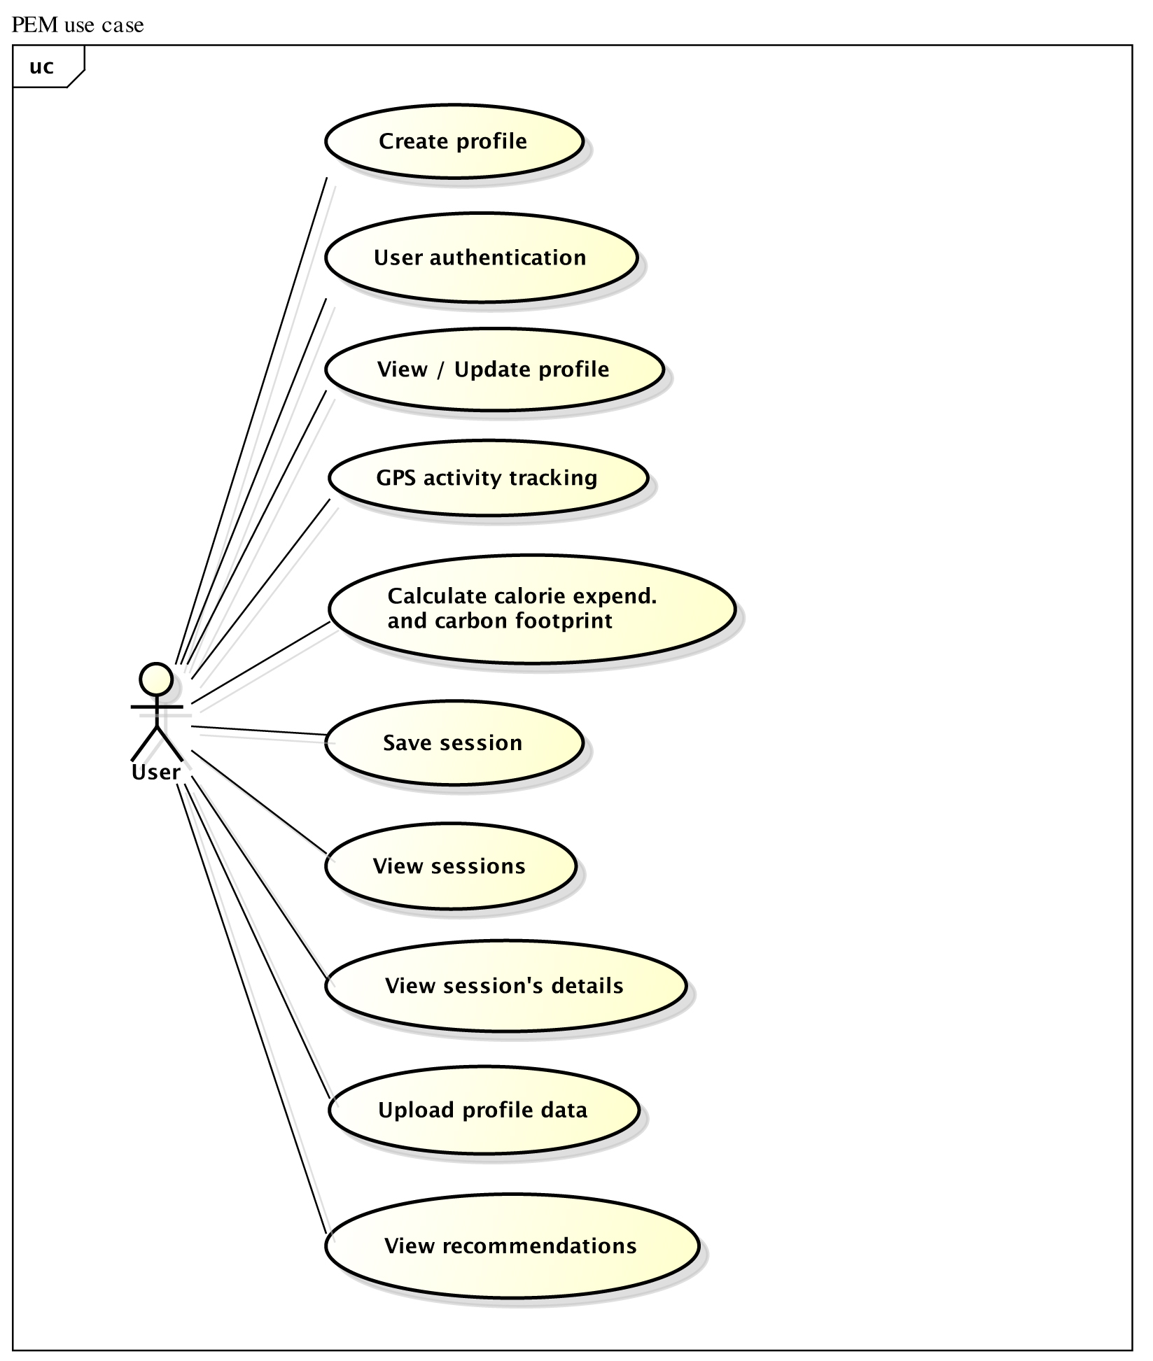

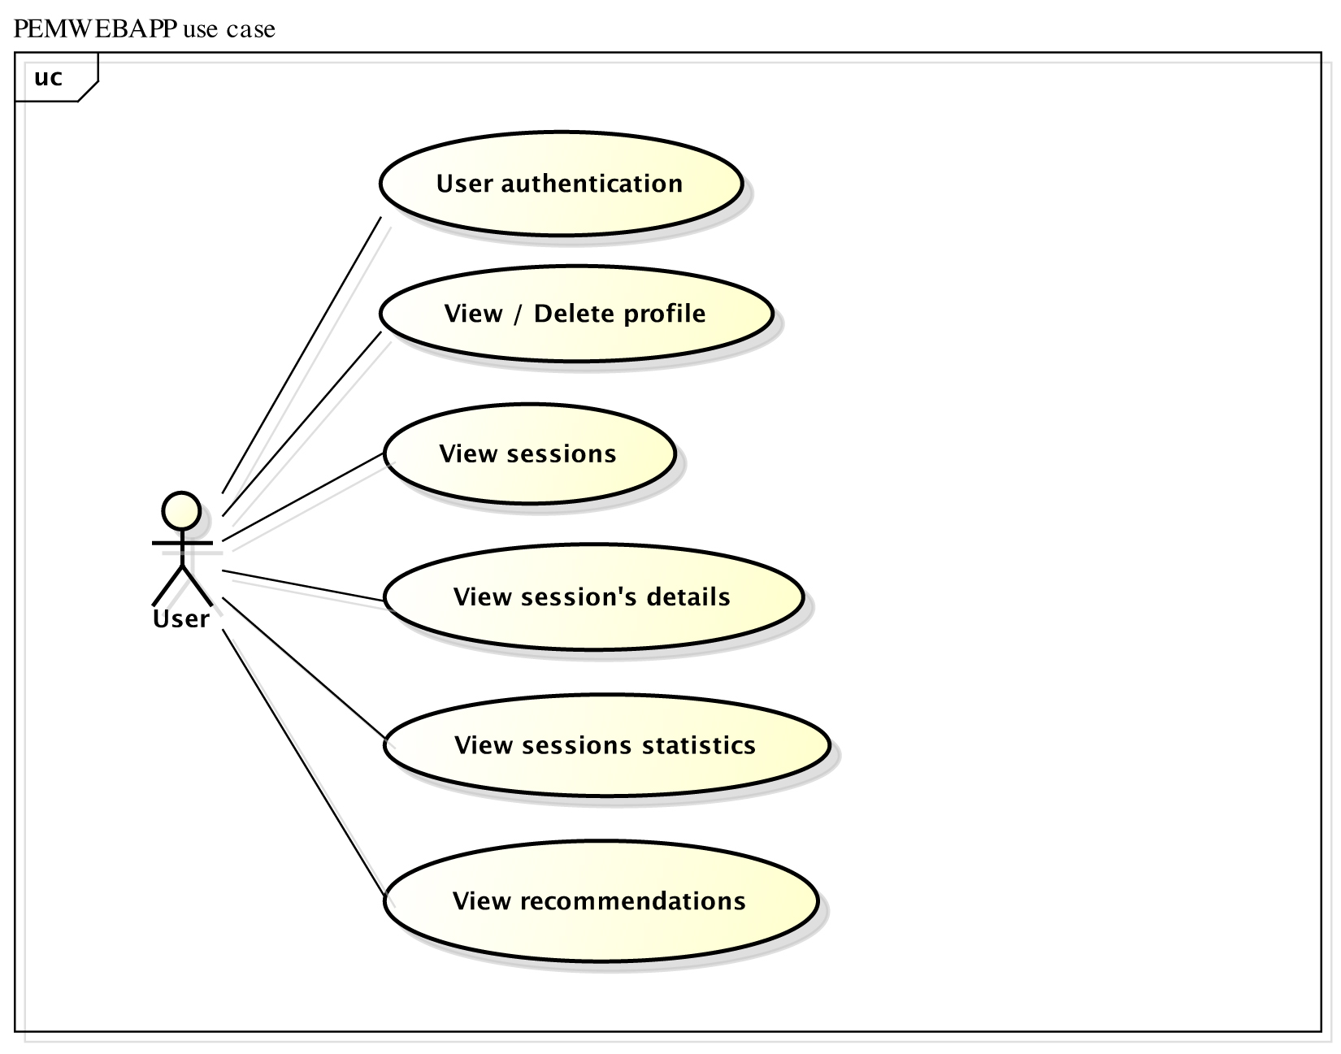

System architecture

To better understand how PEM and PEMWEBAPP applications should be organised, *an architectural design phase* has been used with focus on *a design view* of the applications [REF]. The design view includes architectural patterns, which are outlined below. This level of abstraction allowed both programs to be decomposed into individual components. The only correct way of developing iPhone applications is to follow a Model-View-Controller (MVC) architectural pattern, thus development of the PEM application shall be following it.

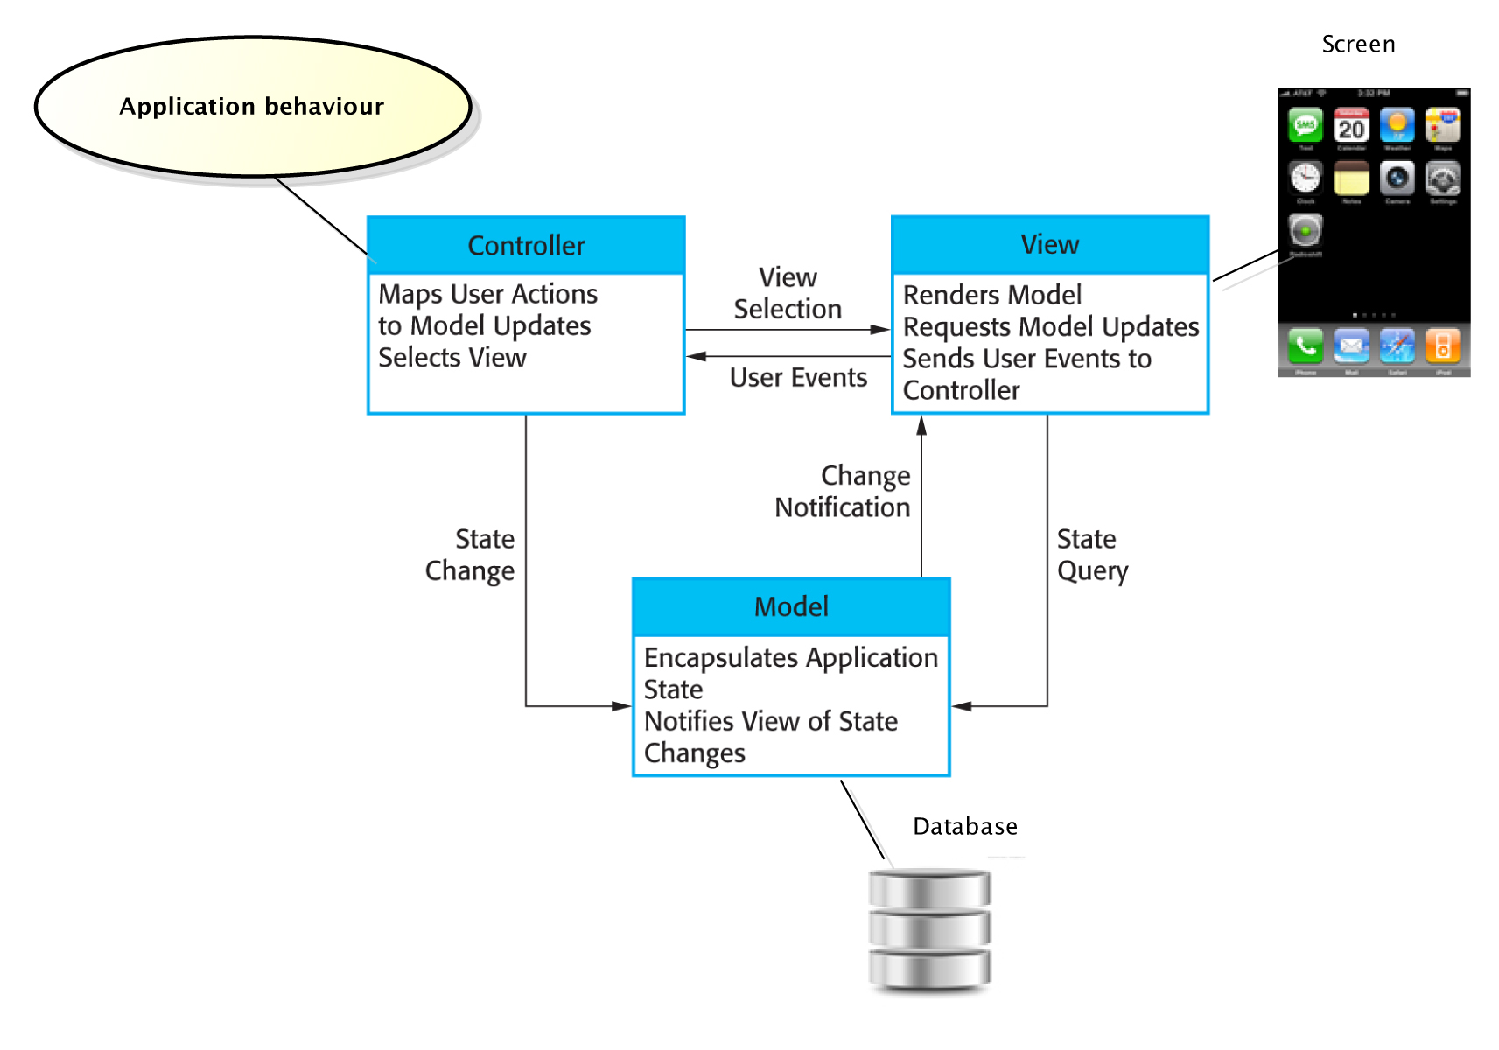

*[PEM MVC][REF]*

Although the PEMWEBAPP application will be deployed on a desktop computer rather than iPhone, it has similar properties to PEM and therefore using the MVC pattern would also be a good choice. However for experimental purposes, *the layered architectural pattern* has been chosen instead as it is another way of achieving separation and independence. Both, PEM and PEMWEBAPP will also comply with the Client-server architectural pattern. Detailed description of mapping both applications on mentioned architectural patterns and justification of choices is presented later in the design phase [*** plus describe what is MVC ***].

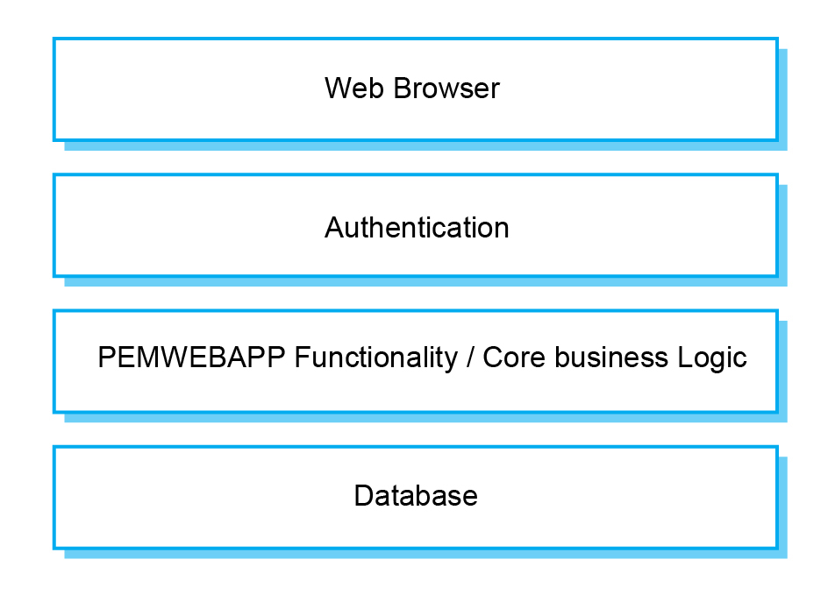

*[PEMWEBAPP layered architecture][REF]*

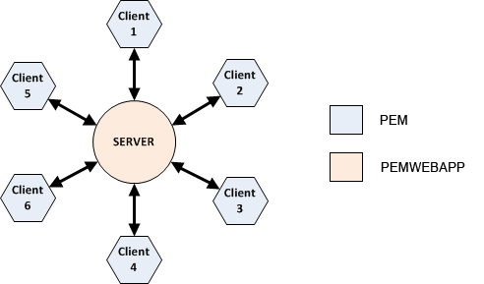

*[Client-server architectural pattern][* *http://www.clear.rice.edu/comp310/f11/lectures/lec26/]*

System requirements specification

**Functional requirements**

**Personal Energy Meter (PEM)**

## 1. Create Profile

This feature shall provide the ability to create a new profile on the PEM. It is the first thing a user must do to begin using PEM. Its main function is to set up a new profile with personal details such as email and password. Email shall act as a username and must be unique. Password must be at least 4 characters long, no longer than 20 and must contain at least one numeric character. No special characters are allowed.

**2. Log-in**

This feature shall allow the user to log in to the existing profile on PEM. When choosing to log in, the user is asked to enter his/her email and password. After a successful authentication the activity screen appears.

**3. Edit profile**

This feature shall allow the user to edit his/her personal details on PEM. When the user is logged in he/she should be able to edit his/her personal details such as adding first and second name or change a body weight. There shall be a constraint on editing the email to preserve correct transfer of data to the appropriate profile on the remote server (email is unique and represents a profile). Password must be at least 4 characters long, no longer than 20 and must contain at least one numeric character. No special characters are allowed.

**4. Delete profile**

This feature shall allow user to delete his/her profile from the PEM. Users not wanting to keep their profile for various reasons or wanting to start from scratch should have an option to delete their profile with all the data gathered. This operation should only affect the PEM system. Users should be able to still access their profile online to see all of the data and results. Deleting online profile shall be done in the PEMWEBAPP.

**5. Start tracking**

This feature shall allow user to start his/her energy expenditure or carbon footprint monitoring. By pressing the Start button, the iPhone device shall start to receive GPS data and at the same time shall perform live calculations of calories burned and/or CO2 emissions calculations. The Location Services on iPhone have to be enabled in order for PEM to receive any GPS data.

**6. Stop tracking**

This feature shall allow user to stop his/her energy expenditure or carbon footprint monitoring as well as to stop receiving GPS data. By pressing the Stop button, user should be prompted if he/she whishes to save a session. Monitoring needs to be in progress in order for Stop to have an effect and ask about saving the data.

**7. Pause tracking**

This feature shall allow user to pause their energy expenditure or carbon footprint monitoring as well as to stop receiving GPS data and resume it all again.

**8. Google maps and tracking information**

This feature shall allow user to see live position on Google maps and GPS data as they are received in intervals (every second). Data such as horizontal accuracy, elevation, distance traveled, grade, speed, time, VO2, Calories and CO2 emissions should be displayed under map view. The map view should be zoom-able and follow user current position.

**9. Sessions view**

This feature shall allow user to navigate through all saved sessions (related to his/her profile) and choose desired session to show in the details view. This view shall pull limited session data from the PEM’s database to show only a session name and timestamp. User should be able to delete the session from this view by swiping the session cell or by using an edit button.

**10. Session details view**

This feature shall allow user to see session details. View shall contain all information gathered by GPS tracking and also results of calculations (session name, timestamp, activity, horizontal accuracy, elevation, distance traveled, grade, speed, time, VO2, Calories and CO2 emissions). Most important data such as total calorie expenditure or total CO2 emissions should be emphasized using graphical aids.

**11. Recommendations**

This feature shall provide the most important information and facts about a type of activity monitored. For example if the Walk or Run activity has been monitored and stored the feature should provide relevant information about recommended amount of daily calorie intake and guidelines on how to lose or maintain weight. For sessions, which monitored activity such as Car, Bus or Train, recommendations should advice user about ways on how to reduce carbon footprint.

**12. Upload profile**

This feature shall upload user’s profile with all sessions to the remote PEMWEBAPP. This operation should be available at any time after user profile has been created.

**13. Log-out**

This feature shall log user out from the PEM.

**PEM Web Application (PEMWEBAPP) – functional requirements**

**1. Log-in**

This feature shall allow the user to log in to the existing profile on PEMWEBAPP. When choosing to log in, the user is asked to enter his/her username and password. After a successful authentication a profile view appears.

**2. Profile page**

This feature shall allow user to see his/her profile. Information such as first and last name, email and body weight should appear as user entered them in the PEM. Password shall not show in this view. None of the information shall be editable.

**3. Delete profile**

This feature shall allow a user to delete his/her profile from the PEMWEBAPP. Users can delete unwanted profile together with all the data gathered. This operation can’t be undone.

**4. Sessions page**

This feature shall allow user to navigate through all uploaded sessions (related to his/her profile) and choose desired session to show in the details view. View shall pull limited session data from the PEMWEBAPP’s database to show only a session name and timestamp. None of the information shall be editable.

**5. Session details page**

This feature shall allow user to see session details. View shall contain all information as they were stored by PEM (session name, timestamp, activity, horizontal accuracy, elevation, distance traveled, grade, speed, time, VO2, Calories and CO2 emissions).

**6. Statistics page**

This feature shall allow user to see statistics of recorded activities in a line chart. Line chart shall show Calories burned and CO2 emissions for each session.

**7. Recommendations**

This feature shall provide the most important information and facts about a type of activity monitored (very similar to PEM’s recommendation feature with exception that it should be accessible from the statistics page rather than session details page).

**8. Log-out**

This feature shall log user out from the PEMWEBAPP.

**99 Non-functional requirements**

**99.1 Product requirements**

**Usability and user experience:**

Following are the Human-Computer-Interaction guidelines against which the PEM application should be evaluated. PEMWEBAPP should be also evaluated against these guidelines where appropriate.

**Usability goals**

1. Effectiveness: energy and calorie estimates must be of the highest accuracy possible for the application to be effective.

2. Efficiency: the application needs to have immediate response and perform live calculations

3. Safety: safe storage and data transfer is critical for this type of application and users should not have to worry whether their data is safe.

4. Utility: PEM should be build correctly and do only what is its intention to maximize utility. There should be no adverts or misleading content.

5. Learnability: PEM must be easy to learn. Following Apple’s Human Interface guidelines, the Norman’s design principles and using well identifiable buttons and other UI controls will be necessary to achieve this. Furthermore, the application must be simple to use for users who are complete novices. It must have step-by-step instructions for initial setup, tracking and data upload. Option selection should be constrained to prevent wrong choices. There is no need for extra flexibility or shortcuts for advance users because the PEM will be very easy to use with a limited number of features.

6. Remembering: PEM will be a multiscreen application. To maximize recognition rather than recall, each screen will have unique elements wrapped into consistent design used throughout the application.

**Experience goals**

1. Satisfaction: the PEM should invoke satisfying feeling when it proofs itself effective.

2. Enjoyment, Fun and Entertainment: PEM should strive for this goal by using simple, responsive and swift GUI. The session details view could be a good place investing into creativity.

3. Helpfulness: PEM should deserve this goal by being reliable and delivering correct data when needed. Users then can make wise decisions based on application’s recommendations.

4. Motivation: PEM should be able to motivate people to reduce carbon footprint and motivate them to live healthily.

5. Aesthetic: PEM should have aesthetic qualities if the design will follow the design principles and human interface guidelines.

6. Support: PEM should have a help section which is easy accessible and readable.

7. Reward and Emotional fulfillment: Users of PEM should be able to feel rewarded and emotional fulfilled for helping to improve their health and planetary wellbeing.

## User Interfaces:

PEM user interface shall be made of various forms, views and pickers all of which are standard iPhone UI components. It should consist of following screens (Login, Activity, Profile, Tracking, Save session, Sessions and Session details). Tab bar at the bottom of the GUI will allow switching between individual screens.

PEMWEBAPP user interface shall be made of Java Servlet Faces and third party PrimeFaces components, which support AJAX for better user experience. It should consist of the following pages (Login, Profile, Sessions, Session details and Statistics). To navigate through the website, standard top-horizontal navigation consisting of links shall be used.

**Efficiency requirements**

1. PEM’s monitoring feature should be able to pin point most accurate current position within 10-20 sec outdoors.
2. iPhone’s inaccurate altitude data received from GPS shall be replaced with accurate elevation data. For this purpose the Google Elevation API shall be used

**Security requirements**

1. Both applications shall use hashing of stored data
2. Use secure data transfer
3. User authentication

**99.2 Organizational requirements**

**Platforms and languages**

1. PEM – Apple (Objective-C)
2. PEMWEBAPP – Oracle (Java Enterprise Edition)
3. PEM - SQLite database wrapped by Core Data
4. PEMWEBAPP - MySQL database

**Interoperability**

PEMWEBAPP shall be implemented as a RESTful service so that iPhone can communicate with it using GET and POST commands.

**Metabolic and carbon footprint calculations**

PEM shall make use of the ACSM’s Metabolic Calculation Handbook for calculating VO2 and consequently calculating of Calorie expenditure.

PEM shall make use of the Carbon Trust’s passenger transport conversion factors for calculating carbon footprint.

**99.3 External requirements**

The PEM must be built correctly to pass Apple’s requirements for application distribution in the App Store. Both PEM and PEMWEBAPP must comply with the Code of Conduct and the Code of Good practice and must use secure file transfer to online website, cannot violate personal privacy by broadcasting user’s location and location history must be stored securely.

System models

Following models are activity diagrams of both applications. First diagram was created in the initial stages of development where as the second diagram was created in later stages of development where more knowledge and experience has been acquired.

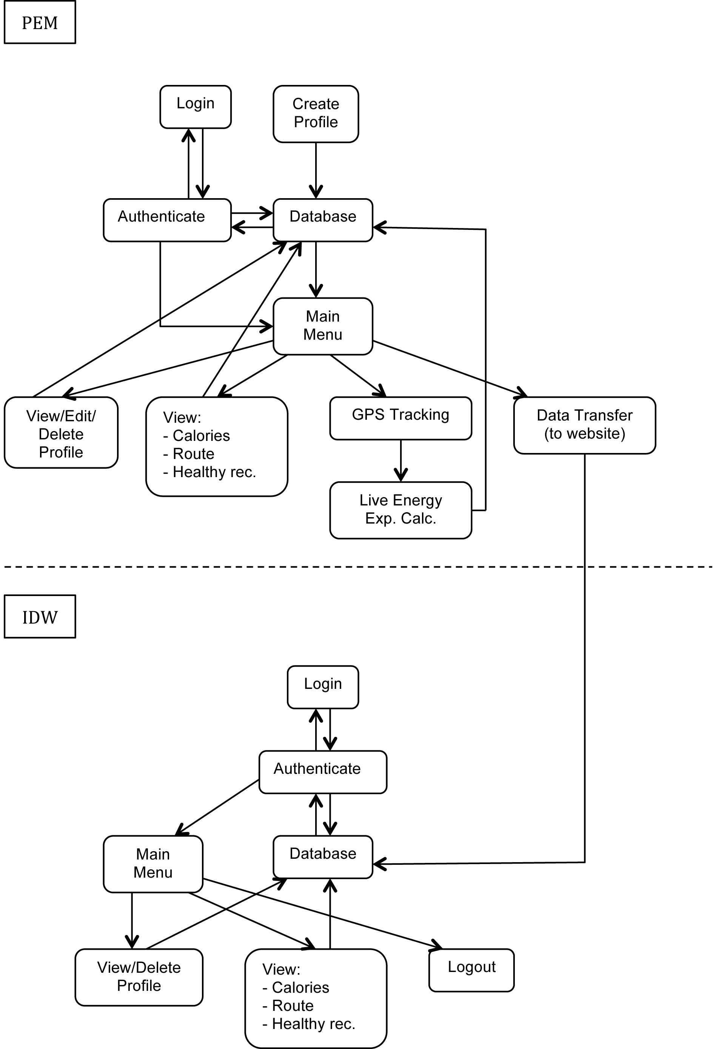

Initial object diagram showing interactions between PEM and IDW (aka. PEMWEBAPP)

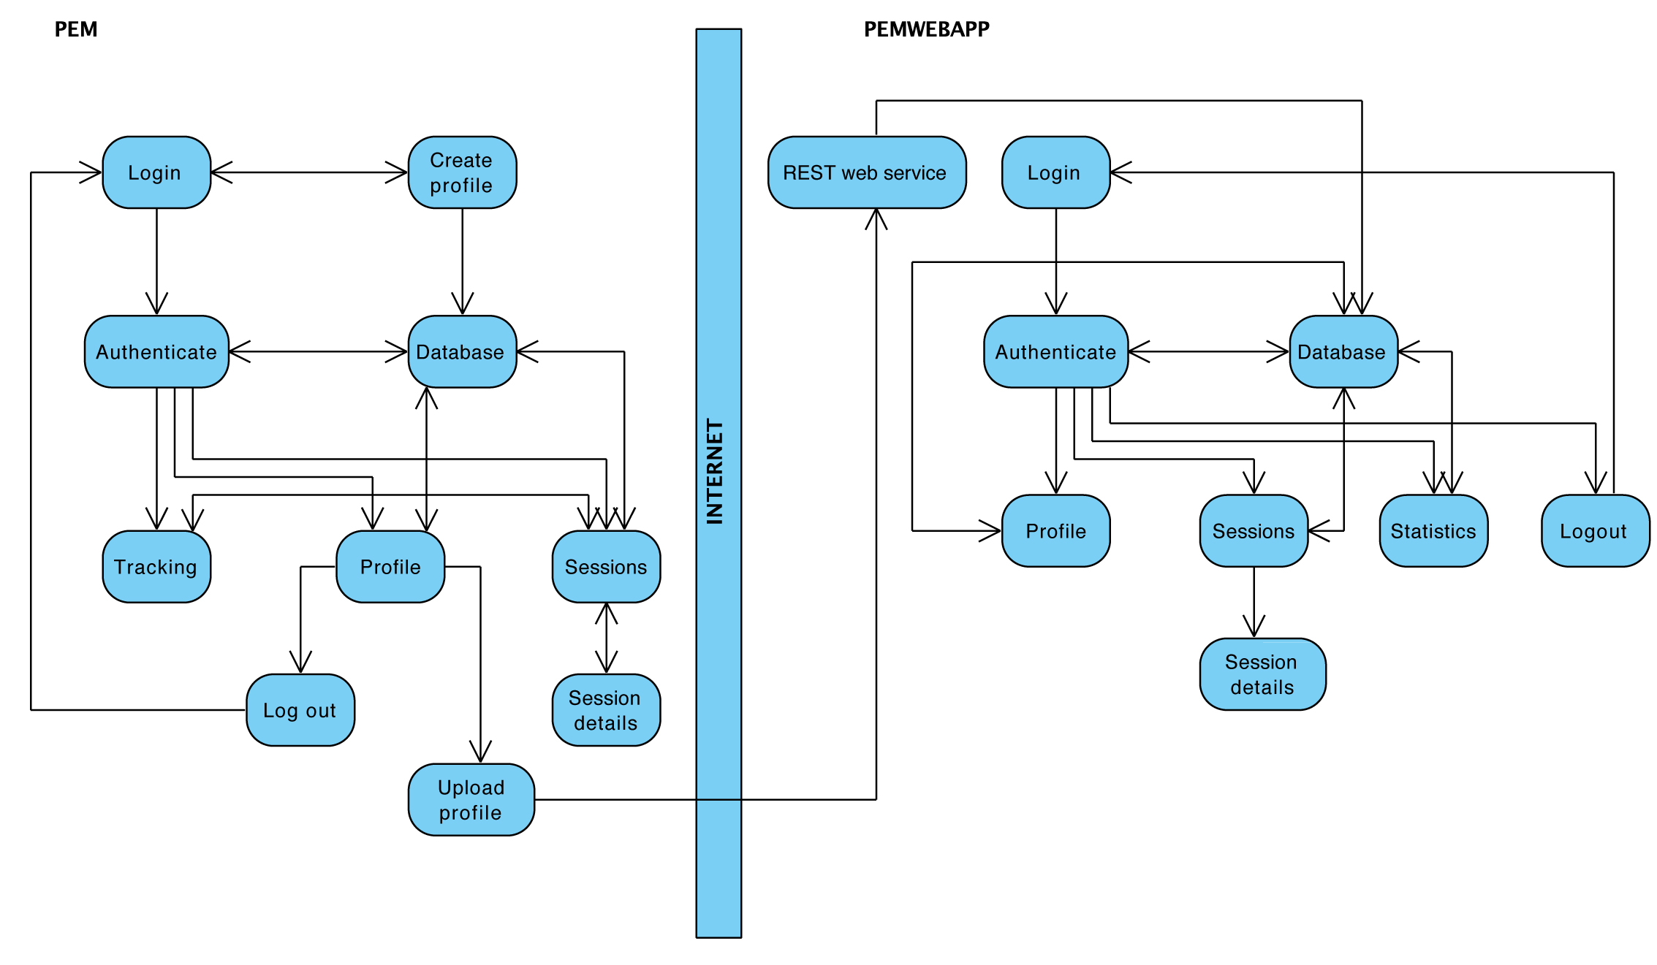

Improved object diagram showing interactions between PEM and PEMWEBAPP in mid stages of development

**Design and Implementation**

Following is the development progress….

Introduction

As already mentioned, the agile software development was most appropriate for this project and therefore there was no solid design in the initial stages of PEM and PEMWEBAPP development.

The design was being developed continuously by getting ideas, proposing solutions, and refining these solutions as information became available during the sprint cycles. Many times there was a need to backtrack and re-design when problems arose [REF – Chapter 7.1]. Paper sketches and Xcode’s storyboards were the only key documents from which the development initiated. There was a time when vast majority of the PEM had to be redesigned as knowledge of an iPhone development improved and having a detailed design beforehand would be a waste of time.

**Building a simple iPhone application**

Project has initiated by first meeting, which focused on chosen project topic. Discussion covered available hardware and software and was aimed on encouragement to learn a new programming language. First stage of the Scrum method, the planning, included gathering requirements, getting to know an iOS development and Xcode IDE, registering in an Apple Developer Program and configuring a computer to be able to deploy applications to an iPhone. First sprint cycle was launched as soon as basic knowledge of an iPhone development has been acquired and some requirements gathered, resulting in creation of a simple iPhone application.

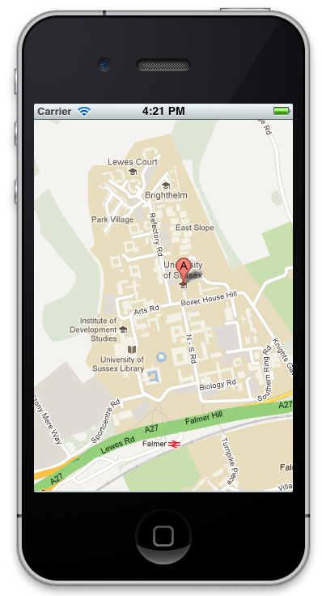

The application was able to pinpoint user’s current position and show it in a map view. To build this simple application a fundamental iPhone development design pattern had to be used, the MVC pattern. A view was built in the Xcode’s Interface Builder and wired up to the application’s logic. This logic was written in an ordinary class, which was a subclass of a UIViewController (User Interface View Controller) providing more functionality. At this stage there was no persistence store to persist application’s data thus the Model part of the MVC pattern wasn’t fully utilised. Figures below show iPhone’s application key objects and how the functionality was wired up to the user interface.

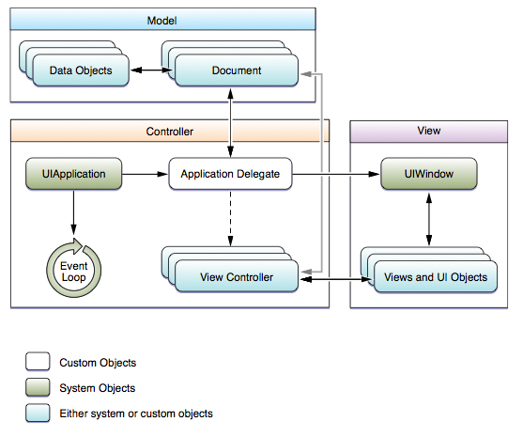

[REF Apple programming guide]

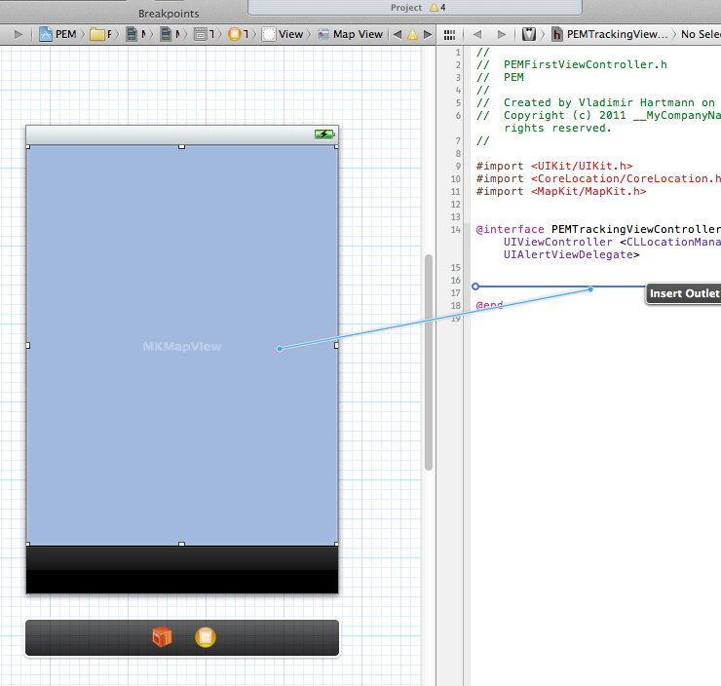

[Wiring up the functionality to the user interface]

**Improving the simple iPhone application**

Demonstration of the simple iPhone application to the customer/supervisor completed the first sprint cycle and at the same time initiated a next one with emphasis on importance to write as much code as possible without worrying about detailed design. Main tasks of this cycle were further programming of the simple iPhone application, a research of previous attempts to build PEM, study of the Apple’s Human-Interface guidelines and gathering a literature about utilising location services on iPhone and about GPS in general. As a result a GPS application was built that could capture location coordinates of current position and display them on iPhone screen.

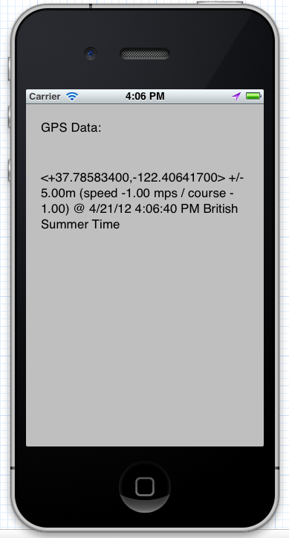

**Utilizing Apple’s Core Data and Core Location**

Following two sprint cycles were mostly concerned with iPhone data persistence and location services.

There are many ways how to persist data on iPhone devices such as using property lists, archiving, directly interfacing with SQLite or using the Core Data framework. First two approaches were not very suitable for storing big amounts of data. Utilising the SQLite and directly interfacing it would work just fine, but Apple introduced more elegant solution of working with relational databases. Core Data allows programmer to think of their data model in terms of objects/entities and their relationships. This is important as the code can retrieve and manipulate this data on a purely object level with simplified fetch requests and there is no need to work with relation schemas and complicated query language which can introduce errors or security issues.

Because receiving location data is not enough to estimate user’s calorie expenditure it was necessary to learn about Core Location.

Core Location is an iOS framework, which allows easy access to the iPhone’s GPS. Precise Apple’s description is:

“The Core Location framework lets you determine the current location or heading associated with a device. The framework uses the available hardware to determine the user’s position and heading. You use the classes and protocols in this framework to configure and schedule the delivery of location and heading events. You can also use it to define geographic regions and monitor when the user crosses the boundaries of those regions.”

[REF]

It is important to mention that during assessments and reviews of these sprint cycles discussion on how to improve accuracy was also relevant. GPS hardware in Apple’s devices as well as in any other mobile device currently on market is well known for producing inaccurate altitude data. This is mostly due to position of satellites, which calculate the altitude [REF <http://weather.gladstonefamily.net/gps_elevation.html>]. One of the suggested project extensions was implementation of signal processing for heart bean measurements. This technique, if implemented correctly, would prove very accurate for estimating calories expenditure as it could be used in situations where user’s position is not changing much but calories expenditure is being high e.g. working out in a gym. The signal processing approach is though big subject on its own and soon became apparent that realisation of this technique would need far more time than allocated for final year project.

At the end of the cycles a first PEM prototype was built which featured everything previously built so far plus measuring the distance. Extensive GPS data filtering had to be done in order to work with gathered data. For example lots of invalid location data was received during Core Location initialization with values differing up to 500m. These had to be filtered out by checking their timestamps or specifying a threshold. Core Location uses caching for storing previously gathered data to prevent frequent use of the GPS. For real time application such as PEM however, this would cause old data to be processed in later implemented calculations. Compromise had to be made to trade battery life for up-to-date data.

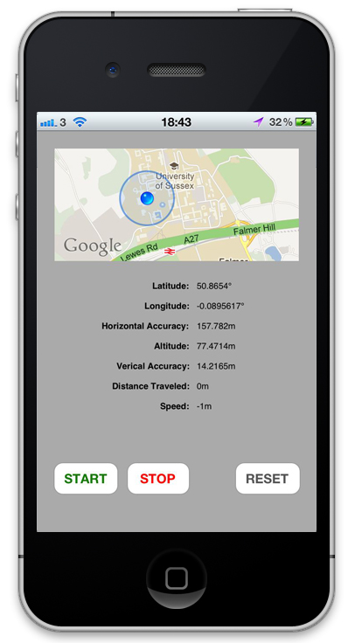

**Building a multi-view iPhone application**

From this point on in the development of the PEM the sprint cycles span through up to 4 weeks. Communication was done mostly via emails and meetings took place once a month on average. This was due to increasing complexity of implementing new features and other factors such as coping with workload from other course modules.

The fifth sprint cycle was mostly concerned with building graphical user interface (GUI) and migrating from Xcode 3 to Xcode 4.

With a purchase of a new MacBook Pro, there was a possibility to run newest software, which was previously impossible due to old computer. Xcode 4 was a major re-write of this IDE and introduced new ways of creating iPhone applications. A feature of *storyboards* added to Xcode’s Interface Builder (IB) enormous power as the GUI could be build from multiple views placed on a single IBs *canvas* resulting in more streamlined development. The Xcode migration was somewhat challenging though. Any prior knowledge of the iPhone development wasn’t fully compatible with new version of Xcode and new knowledge of the same fundamentals already learned had to be acquired. This unexpectedly slowed down the development, which got back to normal when new techniques learned proved more efficient.

As the knowledge of the iPhone development improved, in addition to MVC, concepts such as delegation and protocols had to be utilised in order to establish communication between multiple views or creating custom iPhone functionality.

Delegation can be thought of as a design pattern. In the world of iPhone development it can be explained as follows. Apple designs some basic, standard functionality for example for how the iOS should respond to user’s actions. This functionality is defined in some class e.g. UIViewController which can be thought of as a *protocol*. Developers of iPhone applications can make use of this protocol by declaring it in a custom class they are developing. All UIViewController functionality will now be *delegated* to this custom class. Developers can now use all that functionality without writing any code or build on top of it to make more sophisticated behaviour. Using a delegation is a recommended standard and is inevitable for building correct iPhone applications.

Result of the fifth sprint cycle was a PEM prototype extended by multi view functionality. With introduction of multiple views, the application’s features could be re-distributed allowing for more user-friendly design and more advanced functionality.

Challenges faced here where how to share data between views. As previously mentioned, the PEM’s functionality was directly implemented in the controller class or in other helper classes, which linked to it. This controller class was a subclass of UIViewController and therefore had to obey certain rules. A design of the iOS and the iPhone’s application runtime loop for example does not allow to directly access variables in one controller from another. Further investigation had to be done to solve this problem. It turned out that there are various ways how to go about this issue. Some of them are correct and standard recommended by Apple, others are easier to understand, not recommended, but working just fine. A first approach learned to solve the issue of data exchange between controllers was using a singleton pattern. This is not Apple’s standard, but is widely used and working well (more elegant way will be described later). A singleton is a class from which only one object instance can be created. This assured a single point of access. The idea was to create a singleton class (PEMDataCenter) with needed variables to share. When the controller needed to pass data to another controller, it would first store the data into PEMDataCenter. This way the data were available for use by another controllers. Following figure shows a dummy GUI with hard-coded data. There is a login screen, create profile screen, tracking screen, sessions screen, session details screen, profile screen and a sliding menu providing more options which are hidden away to prevent cluttered design. Feature such as automatic text field movement (if a form accommodates more than size of the iPhone screen) was also implemented.

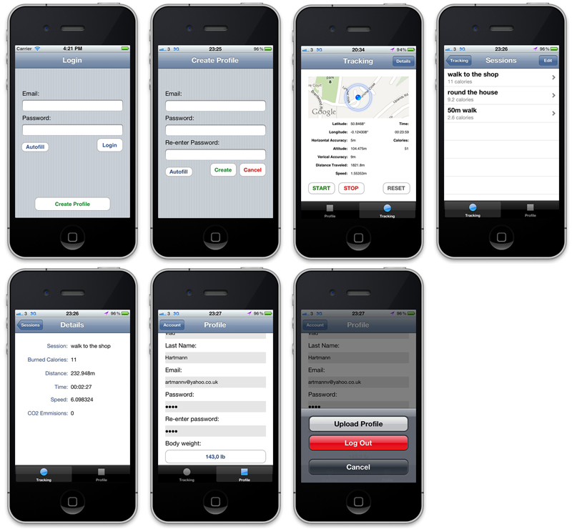

Next sprint cycle

[ 13. Dec 2011 ] - Wrote and implemented algorithms for user login and create account features

[ 14. Dec 2011 ] - Implemented user profile management

[ 19. Dec 2011 ] - Refactoring the app

[ 27. Dec 2011 ] - Building an Action sheet for option selection

[ 01. Jan 2012 ] - Building a sliding picker view for age selection

next sprint cycle

[ 02. Jan 2012 ] - Research on calorie burn calculation (different ways of estimation)

[ 03 Jan 2011, 15.00 ] No meeting but email  
- Discussion of Using heart rate (plug into simple equation)  
2. Using heart rate + VO2max (plug into simple equation)  
3. Naive methods with charts of calorie expenditure (no distance needed only time)  
4. Working out the work (Work = Force x Distance)  
5. Kinetic energy (equivalent to 4.)The question you need to ask yourself is: how can you measure hear-trate and CO2 consumption?

I would imagine that this cannot be done with a bare iPhone, and you'd need some extra hardware.

I'm not against using extra hardware, but I wonder if going this route is the best way forward. How do

Hay, Rassia, and Beresford in "Estimating personal energy expenditure with location data" solve this problem?

[ 09 Jan 2011, 14.00 ]70% of my iPhone app is done = working prototype tracking a walking activity. Now filtered with very accurate positioning.  
Using only simple calorie expenditure model.

I bought this book:

http://www.amazon.co.uk/Metabolic-Calculations-Handbook-American-Medicine/dp/0781742382and working on more sophisticated model.

It's based on estimates of VO2/1kg moved by 1m.

Inputs such as person weight, track distance and grade/slope are inputs of the equitation.

By following this technique I will get accurate energy expenditure estimates for Walking, Running or Stepping/Cycling activities.[ 22 Jan 2011, 13.00 ] - Hello Vlad, here's a guy who writes his PhD onAs part of that he compares various fitness apps:

http://quantifiedself.com/2011/05/fitbit-vs-body-media/ http://tedphd.posterous.com/Maybe there's something useful for your project.  
[ 04. Jan 2012 ] - Changed age to weight in Profile view. Implemented tracking view. Implemented a count up timer

[ 03 Feb 2011, 13.00 ] I have done some progress:

- Built a demo web application with MySQL database running in GlassFish on localhost

- working on securing the access (user login)

- purchased VM hosting and configured for running my web app remotely

Can I see you sometime next week?  
[ 02. Feb 2012 ] - MySQL setup and connecting IDE with database

[ 03. Feb 2012 ] - First Java web application implementd

[ 19 Feb 2011, 13.00 ] just a quick update:

I am doing well. Able to code the website and implement the iPhone - web application protocol.

Currently busy with a web application and services module (lots of context, far more advanced

then my project website should be). But will use lots of knowledge in my final year project.

My estimate is to finish coding a project in first two weeks of a spring break and then finish the report

in a third week.

Is this acceptable given that we should hand the draft in week 10?

It will be for me almost impossible to do that by week 10 as my assignment from web applications is very

difficult.[ 01 March 2011, 13.00 ] I am nearly done with one of my assignments for Web Apps and services module (which took most of my time in this term).

However I have constructed a web application which I can use in my final year project.

I have still two more assignments to do (week 9, 10), but I will also do some work on my draft report.

From your and the 2nd marker's feedback I know what I need to work on. Also I know you are

quite interested in the precision and evaluation of my iPhone app results.

I will focus also y effort to address these. I will not be able to write in details about these issues

till week 10, but will write something to get more feedback.

I need 2 weeks to finish coding and 2 weeks to write up the final report.

I will have almost 6 weeks in total from 17. March to 26. April and I would like to spend this

time developing it properly.[ 12 March 2011, 12.30 ] final discussions

Initial paper sketch scan….

Initial storyboard image….

Some initial design issues…

It was difficult to pinpoint the exact stage for somehow solid design, however when the applications started to grow and there was a potential for scalability and maintainability further development was becoming difficult to manage. Bearing in mind possible changes to the systems in future the object-oriented design (OOD) seemed the most appropriate. Because OOD supports modularity, independent objects can be easily changed without affecting overall system. Following are the steps used to develop a system from concept to detailed, object-oriented design, as described by Ian Sommerville [REF].

1. Understanding and defining the context

It was known from the start of the project that the system will consist of an iPhone application (PEM) and dynamic website (PEMWEBAPP). It wasn’t too obvious however that the system will be extended by a third party service Google Elevation API (GEAPI).

**Google Elevation API (GEAPI)**

The GEAPI is a RESTful web service, which provides accurate altitude data. GEAPI is free to use and devices or other software make use of it by sending a GET requests to it with latitude and longitude coordinates. Service responds with the altitude value. The response is formatted either in XML or JSON.

**JavaScript Object Notation (JSON)**

JSON is a lightweight data-interchange format, based on the JavaScript programming language. It is easy to read and write for humans and easy for machines to generate and parse. JSON is language independent but uses conventions of the C-family of languages.

JSON file is built from a collection of name/value pairs (hash table, keyed list) and an ordered list of values (array, vector, list).

Example of a JSON file:

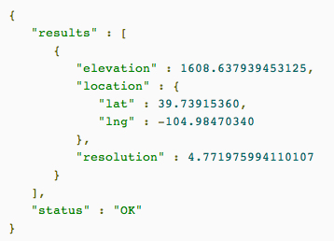

**RestKit**

RestKit is an Objective-C framework for iOS that makes interacting with RESTful web services simple and fast. It combines a HTTP request/response API with an object mapping system. This reduces the amount of code a developers need to write so they can focus more on their data model and worry less about the details of sending requests, parsing responses, and building representations of remote resources.

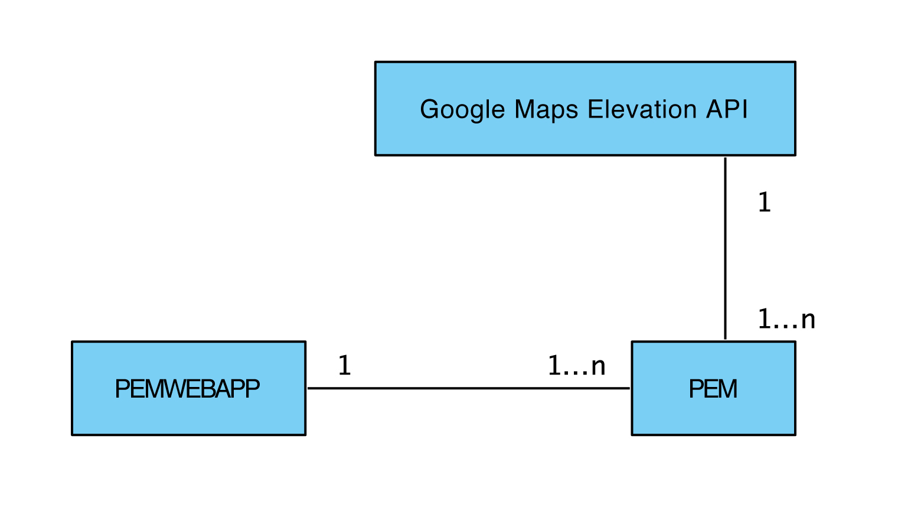

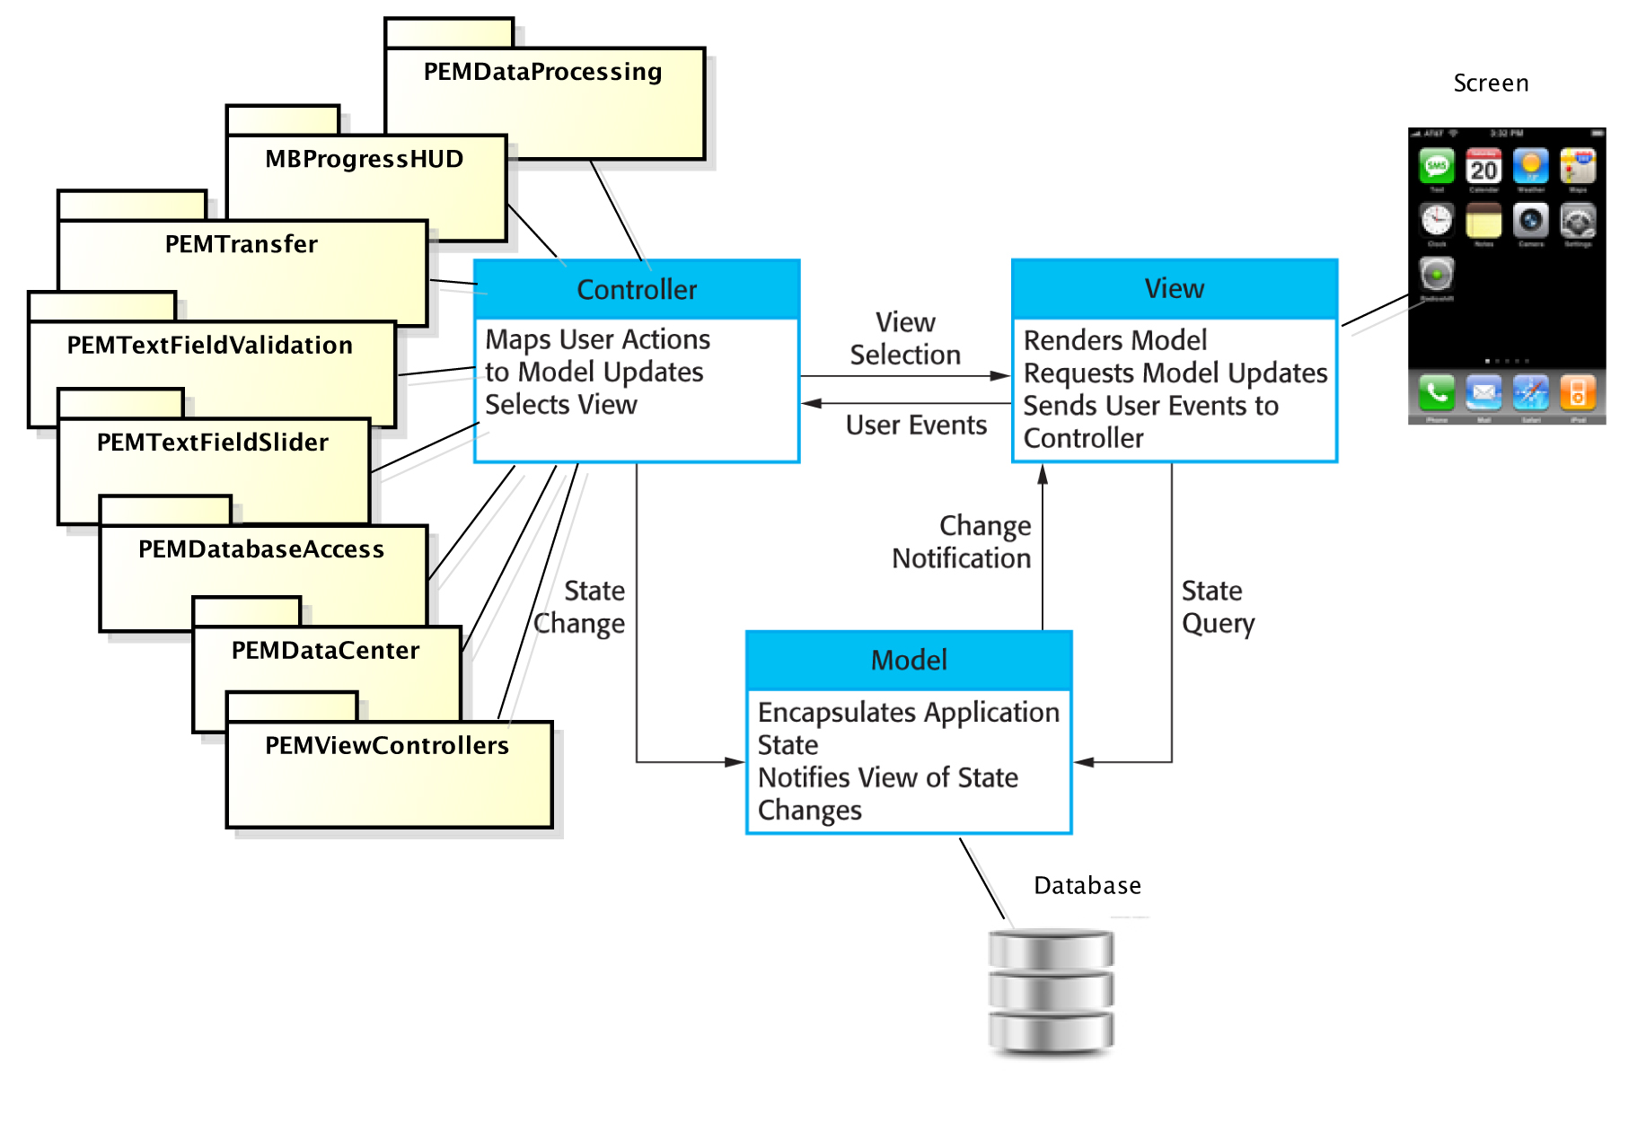

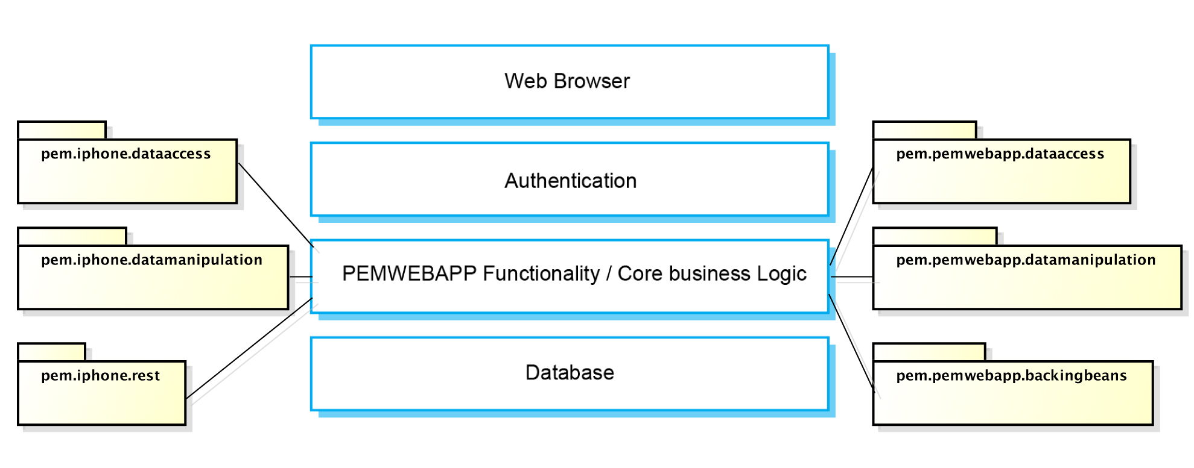

* **Evaluation / testing**

**9. Conclusion**

**10. References**

**11. Appendices**

* **Logs**

**Interim Log**

**22 Sep 2011, 1pm** - Initial meeting, focusing on the project topic

**03 Oct 2011, 4pm** - Discussed further chosen topic, its objectives and extensions

**10 Oct 2011, 12.30pm** - Demonstration of my first iPhone application

**17 Oct 2011, 12.30pm** - Discussed focus on starting to program ASAP even before the design is completely done (emphasis on agile method)

**24 Oct 2011, 4pm** - Demo of my GPS data gathering app, discussion of signal processing methods to improve accuracy of energy expenditure, discussion of GPS data storage

**31 Oct 2011, 12.30pm** - Demo of my iPhone app and the storage implemented using Apple’s Core Data

**07 Nov 2011, 12.30pm** – Demonstrating the first PEM prototype, discussion about GPS altitude accuracy

**Project Proposal**

**Name:** Vladimir Hartmann

**Name of supervisor:** Dr. Martin Berger

**Working title:** Estimating personal energy expenditure with location data  
*(based on previous work of Simon Hay, Stamatina Th. Rassia, Alastair R. Beresford at University of Cambridge)*

**Aims and objectives:**

Modern society is putting unsustainable demands on personal wellbeing as well as the wellbeing of the planet. Pervasive sedentary lifestyle has been creating many health conditions while excess in energy consumption has had adverse effects on our ecosystem. There is a clear connection between personal and planetary wellbeing and actions that help to improve our own health often have a positive effect on our environment. Location data such as GPS tracking can be utilised to address both issues. As it is most frequently collected piece of contextual data in computing, it can be applied to many healthcare applications. This technique offers a number of improvements over traditional methods which involve carrying a dedicated accelerometer device.

Aim: To estimatepersonal energy expenditure and provide healthy recommendations for personal and planetary wellbeing.

Objectives:

Primary: **Design and develop the Personal Energy Meter (PEM), an iPhone application that is capable of:**

* Capture and process GPS data
* Calculate calories expenditure using an Energy Consumption Model
* Calculate a carbon footprint
* Graphically output the results of the calculations
* Give recommendations on personal and planetary wellbeing

**Design and develop an interactive website which is capable of:**

* Create and maintain user profiles
* Receive and process the data from the PEM, an iPhone application
* Graphically output the results of the calculations
* Give recommendations on personal and planetary wellbeing

Extensions:

* More precise GPS data processing by PEM
  + Live GPS data categorisation (walking, driving car, running, using public transport)
  + iPhone in-built headphones microphone integration for capturing the heartbeat (for estimating energy expenditure indoors where high volume of energy can be used for example in the gym or climbing stairs)
* Validation of the Energy Consumption Model with real biomedical measurements
* Improve accuracy and reliability of capturing the GPS data
* Share the personal energy expenditure data with other users
* Energy expenditure trends visualisation (personal, carbon footprint)

**Relevance:**

This project is suitable for me to undertake as I can use the knowledge I have acquired from previous years in areas of:

* Programming Languages (I have learned the fundamental principles of programming languages so I am confident to learn Objective C, language needed for an iPhone development)
* Databases (both PEM and the website will need a database)
* HCI (to be able to build right, useful and easy to use GUIs)
* Software Engineering (inevitable for undertaking any project of this size)
* Machine Learning (needed for processing/categorising large amounts of gathered GPS data)
* Networks (very useful for data transfer and online security of this project)
* Web Development (useful for developing the interactive website)

**Personal weekly timetable**

|  |  |  |  |  |  |  |  |
| --- | --- | --- | --- | --- | --- | --- | --- |
| Time | Monday | Tuesday | Wednesday | Thursday | Friday | Saturday | Sunday |
| 08:00 |  |  |  |  |  |  |  |
| 09:00 |  |  |  |  |  |  |  |
| 10:00 |  | Project work |  | Project work |  |  |  |
| 11:00 |  |  |  |  |  |
| 12:00 |  | Lecture | Lecture | Work | Work |
| 13:00 | Lecture |  |  |
| 14:00 | Seminar | Class | Project work |
| 15:00 |  | Society |
| 16:00 | Term module  study | Gym |
| 17:00 | Term module  study | Term module  study |  |
| 18:00 | Project work |
| 19:00 |  |  |  |
| 20:00 | Project work | Skating | Project work |
| 21:00 |
| 22:00 |  |  |
| 23:00 |  |  |
| 24:00 |  |  |  |  |  |  |  |

*Project work: 34h/w*

**Resources required:**

* Mac OSX based computer
* iPhone

All available

**Bibliography of background reading**

* Beginning iPhone Development: Exploring the iPhone SDK (Dave Mark, Jeff LaMarche)
* Learn Objective-C on the Mac (Mark Dalrymple, Scott Knaster)
* Beginning Java EE 6 with GlassFish 3 2nd Edition (Antonio Goncalves)
* Computing for the future of the planet (A. Hopper and A. Rice)
* A global personal energy meter (S. Hay)
* Location systems for ubiquitous computing (J. Hightower and G. Borriello)
* Time spent being sedentary and weight gain in healthy adults (U. Ekelund, S. Brage, H. Besson, S. Sharp, and N. J. Wareham)
* The anatomy of a context-aware application (A. Harter, A. Hopper, P. Steggles, A. Ward, and P. Webster)
* Implementing a sentient computing system (M. Addlesee, R. Curwen, S. Hodges, J. F. Newman, P. Steggles, A. Ward, and A. Hopper)

**List of other students doing related projects**

None

**Interim log**

* 22 September 2011, 1pm – Initial meeting, focusing on the project topic
* 03 October 2011, 4pm – Discussed further chosen topic, its objectives and extensions
* 10 October 2011, 12.30pm – Demonstration of my first iPhone application
* 17 October 2011, 12.30pm – Discussed focus on starting to program ASAP even before the design is completely done (emphasis on agile method)
* **System data**
* **Test data**

What to mention:

1. Any design iPhone or JavaEE constraints mention in non-functional requirements!

What to ask:

1. Where to put project plan in report? It is out of date, should I change it?
2. Libraries in the project?
3. Documents not written by me?
4. User documentation?